Light direction

Julia uses a lamp to light the inside of a box.
She is thinking about how light moves from the lamp.
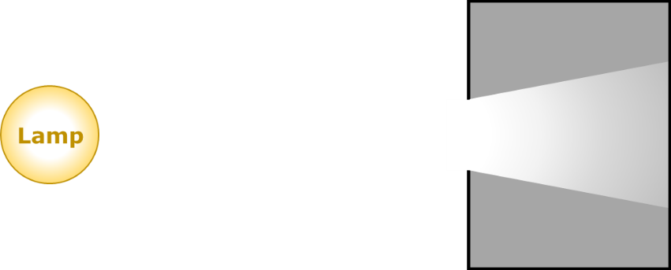

How does light move from the lamp?

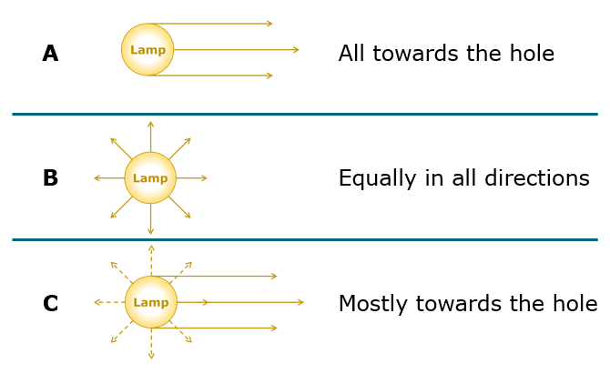
Physics > Big idea PSL: Sound, light and waves > Topic PSL3: Making images > Key concept PSL3.1: The ray model of light to explain images
Diagnostic question
Light direction

Overview
Learning focus: | Only some light rays from each point of an illuminated object can pass through a pinhole, hitting a screen at distinct points to make an inverted image.
Observable learning outcome: | Describe the direction in which light travels from a light source.
Question type: | Simple multiple choice
Key words: | Light ray

What does the research say?
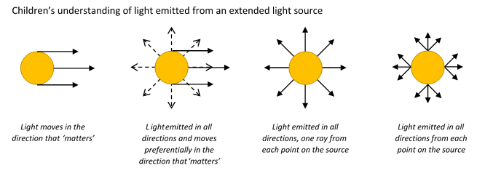
Students’ understanding of image formation is largely dependent on the way they perceive light emission from extended light sources. Rice and Feher (1987) found when students are presented with a lamp in front of an optical device (pinhole, mirror, prism, lens) about half of 9- to 13-year-olds (n=62) described light rays moving parallel to each other from the light source in a ‘preferred direction’ towards the device. This view was maintained even when a cylindrical lamp was used that clearly lit the room in all directions. In Galili and Hazan’s study 40% of students aged 14-16 had the misunderstanding that just one ray was emitted from each point on a light source.
In order to explain image formation students need to understand that a light is emitted in all directions from each point on the source (Rice and Feher, 1987; Dedes and Kanstantinos, 2007; Galili and Hazan, 2000; Andreou and Raftopoulos, 2011).
This question investigates students’ understanding of the first part of this, that light is emitted equally in all directions.
Ways to use this question
Students should complete the question individually. This could be a pencil and paper exercise, or you could use an electronic ‘voting system’ or mini white boards and the PowerPoint presentation.
The answers to the question will show you whether students understood the concept sufficiently well to apply it correctly.
If there is a range of answers, you may choose to respond through structured class discussion. Ask one student to explain why they gave the answer they did; ask another student to explain why they agree with them; ask another to explain why they disagree, and so on. This sort of discussion gives students the opportunity to explore their thinking and for you to really understand their learning needs.
Differentiation
You may choose to read the questions to the class, so that everyone can focus on the science. In some situations it may be more appropriate for a teaching assistant to read for one or two students.
Expected answers
Answer B – light moves equally in all directions.
How to respond - what next?
This question is about the idea that placing an optical device in front of a lamp does not affect how the light leaves the lamp. An optical device affects only the light falling on it.
If students have misunderstandings about how light moves from a light source, it can help to set up a bulb in order to investigate students understanding. The bulb needs to be bright and have no shade, so it shines equally in all directions. Placing a box with a hole in one side (and no top, so the light can be seen to enter) in front of the bulb will show the box lit up by the light. Asking students to predict and explain what they will see if more similar boxes are placed around the lamp will challenge the idea that light is emitted in a preferential direction.
Acknowledgments
Developed by Peter Fairhurst (UYSEG).
Images: Peter Fairhurst (UYSEG).
References
Andreou, C. and Raftopoulos, A. (2011). Lessons from the history of the concept of the ray for teaching geometric optics. Science and Education, 20, 1007-1037.
Dedes, C. and Kanstantinos, R. (2007). Teaching image formation by extended light sources: the use of a model derived from the history of science. Research in Science Education, 39, 57-73.
Galili, I. and Hazan, A. (2000). Learners' knowledge in optics: interpretation, structure and analysis. International Journal of Science Education, 22(1), 57-88.
Rice, K. and Feher, E. (1987). Pinholes and images: childres's conceptions of light and vision. Science Education, 71(4), 629-639.

